Aesthetics and the anthropocene
English 7860 (Autumn 2016)
Class Meet: Tuesday, 9:10 - 12:10 in Denney Hall 311
Professor Thomas S. Davis
Office Hours: Denney Hall 456 (3-4 pm, Thursday and Friday or by appointment)
Email: davis.3186@osu.edu (9 am - 5 pm, M-F)
Mailbox: Denney Hall 421

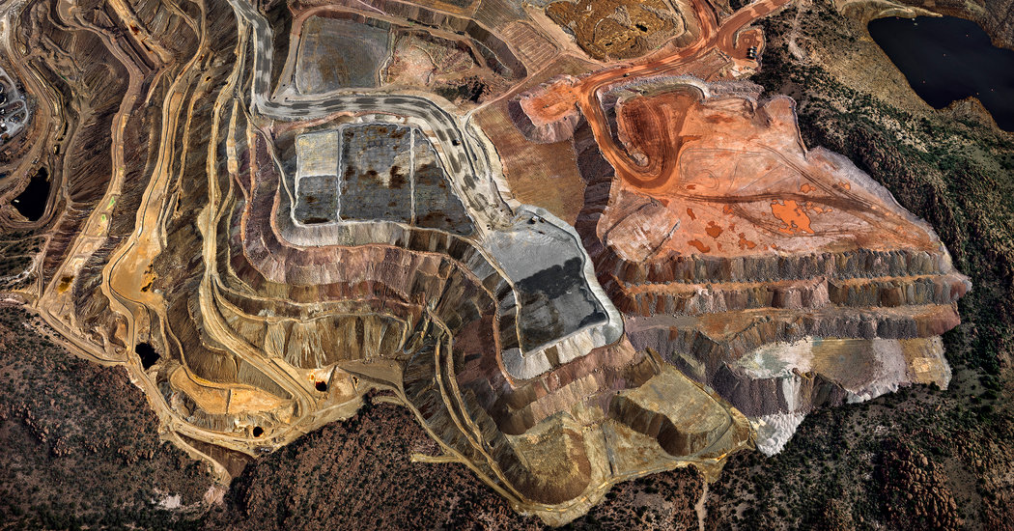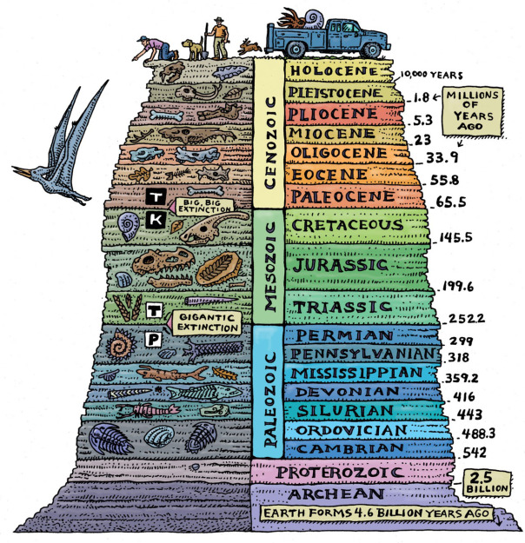

COURSE DESCRIPTION:

The Anthropocene is the proposed name for our current geological epoch, the first in which human activity has dramatically altered atmospheric, hydrologic, biospheric, and other Earth systems. The recognition that humans are a geologic force poses enormous challenges to knowledge systems built around the segregation of historical time and geological time, human and nonhuman nature, and social relations and environment. In many ways, the reality of the Anthropocene strikes at the very heart of the Humanities, which has long privileged human thought, feeling, action, and cultural production.

This class will perform two tasks: first, we will consider the ways the environmental humanities are reshaping modern and contemporary literary studies; second, we will explore the unique ways artworks internalize, configure, disclose and conceal the realities of life in the Anthropocene. We will take up a range of genres, forms, and aesthetic practices--early documentary film, global modernist fiction, activist writing, visual art, petro-aesthetics, dystopic imaginaries and ""cli-fi""--as we try to develop alternative literary histories and reading practices for the Anthropocene.

Required Texts
J.G. Ballard: The Drowned World
Octavia Butler: The Parable of the Sower
Doris Lessing: The Grass is Singing
Samuel Selvon: A Brighter Sun
H.G. Wells: The Time Machine
Virginia Woolf: Orlando

Other readings on Carmen

Course Requirements and Policies:

FOR ALL STUDENTS:

Class Preparation and Participation: In title and form, this class is a seminar. For it to work properly, everyone will be expected to arrive fully prepared to participate. Because this is a fundamental component of the class, there is no grade; however, if I have questions about your participation at any point in the semester, we will meet to discuss them. Also note that all phones and electronic devices should be switched to off.

Attendance: Attendance at every class is mandatory.

Roundtable Discussion (20%): Working in pairs or individually, students will have 15 minutes to (1) articulate a broad problem or zone of interest around the assigned readings and (2) isolate 2 passages for us to discuss. The presenters are charged with providing context for their passages, articulating for us how they align with, illuminate, or complicate broader problems, and instigating discussion with questions and ideas. You will write up components (1) and (2) and compose further reflections from our discussion for the class blog. Sign up for dates to present on Carmen. You will need to indicate to me via email the texts you plan to address at least one week prior to your presentation. One presentation per class session only.

Reports from the Field (10%): Each student will offer a brief (10 minute) summary of an object, practice, or event related to our ongoing discussions in class or to Environmental Humanities writ large. You may select from a wide array of things: new books, conferences, exhibits, films, Environmental Humanities programs and/or centers, video games, stories in popular media, etc. The idea is for us all to be on the lookout for the various ways Environmental Humanities is taking shape within academic and non-academic circles.

FOR GRADED STUDENTS:

Weekly Notes (15% of grade): Students will be required to complete one set of notes per week and submit them via Carmen every other week. These are fairly informal, but they should register close engagement with the texts. Generally, these notes may consist of close readings of particular passages, efforts to grapple with particular concepts or ideas, remarks on perceived connections among texts, and/or articulations of any problems and difficulties you experience while reading. These should be uploaded to the Carmen dropbox before class on Monday by 5 pm. Please use the appropriate week number and your last name (ex. "Davis Week 4") for the file name.

Paper Presentation (15%): During the final week of class we will host conference style panels. You will present your work-in-progress and we will have a Q & A session afterwards. You should plan for a 10-12 minute presentation.

Final Project (40% of grade): Depending on your field, this project can take several forms. If you opt to do a digital project or something apart from a researched essay, we will meet and discuss the parameters for your project. If you opt to write a final essay, you will be expected to compose a thickly researched argument of article length (about 8500 words). You may take up any of the ideas, questions, or problems we discuss in class. All essays will be preceded by a proposal, annotated bibliography, and a short list of journals to which you would send your project. Late work will result automatically in the deduction of a letter grade.

FOR S/U STUDENTS:

Notes: In addition the roundtable and report from the field, S/U students will submit notes on Weeks 4, 8, 12, and 15. These notes should draw from the materials we cover up to the week you submit your notes. Notes need not exceed 3-4 pages.

PLAGIARISM:

Plagiarism is the representation of another's works or ideas as one's own: it includes the unacknowledged word for word use and/or paraphrasing of another person's work, and/or the inappropriate unacknowledged use of another person's ideas. All cases of suspected plagiarism, in accordance with university rules, will be reported to the Committee on Academic Misconduct. If you have any questions about what may or may not constitute plagiarism, feel free to contact me and discuss it.

CLASS CANCELLATION:

In the unlikely event that I need to cancel class, an email will be sent noting the cancellation and a note will be posted on the classroom door. Instructions for the following class will be provided by email as well.

DISABILITY AND ACCOMMODATION:

Any student who feels s/he may need an accommodation based on the impact of a disability should contact me privately to discuss your specific needs. Please contact the Office of Student Life Disability Services at 614-292-3307 in room 098 Baker Hall to coordinate reasonable accommodations for students with documented disabilities. Email: slds@osu.edu

Class Schedule
Week One: Introduction: The Anthropocene
August 23
- Paul Crutzen “The Geology of Mankind”
- Crutzen, Will Steffen, Max Planck, etc.: “The Anthropocene: Historical and Conceptual Perspectives”
- Michael J. Watts "Nature: Culture"
- Anna Tsing, “A Feminist Approach to the Anthropocene: Earth Stalked by Man” (video of lecture)
- 11:10 – 12:10: Visit Orton Geological Museum
Week Two: History and Time, Capital and Climate
August 30

- Dipesh Chakrabarty “The Climate of History: Four Theses”
- Dipesh Chakrabarty: "Climate and Capital: On Conjoined Histories"
- Jeremy Davies from The Birth of the Anthropocene
- Kathryn Yusoff "Anthropogenesis: Origins and Endings in the Anthropocene"

Week Three: Anthropocene Aesthetics
September 6
- Nicholas Mirzoeff “Visualizing the Anthropocene”
- Kate Marshall and Tobias Boes, "Writing the Anthropocene: An Introduction" (60-67)
- Timothy Clark "Derangements of Scale"
- Anna L. Tsing "Nonscalability"
- H.G. Wells The Time Machine
Week Four: Literary History in the Anthropocene
September 13

- Virginia Woolf Orlando
- Jesse Oak Taylor, "Climatic Modernism"

Week Five: Capitalocene and World-Ecology
September 20

- Jason W. Moore, "Capitalocene"
- Bonneuil & Baptiste-Fressoz, from The Shock of the Anthropocene
- Michael Niblett “World-Ecology, World-Economy, World Literature”

Week Six: Late Modernism’s World-Ecology I
September 27

- John Grierson's "The E.M.B. Film Unit"
- Basil Wright "Song of Ceylon"
- Basil Wright "Windmill in Barbados"
- Len Lye "Birth of the Robot"
- Late Modernism Readings

Week Seven: Late Modernism’s World-Ecology II

October 4
- Samuel Selvon A Brighter Sun
- John McNeill, from The Great Acceleration
- Rob Nixon from Slow Violence and the Environmentalism of the Poor

Week Eight: Late Modernism's World Ecology III
October 11
- Doris Lessing, The Grass is Singing
- Ursula K. Heise, from Sense of Place and Sense of Planet

Week Nine: Literary and Political Ecologies: Petro-Aesthetics
October 18:
- Jane Bennett, from Vibrant Matter
- Patricia Yaeger "Literature in the Ages of Wood, Tallow, Coal Whale Oil , Gasoline, Atomic Power, and Other Energy Sources," PMLA 126.2 (305-311)
- Lawrence Buell, "A Short History of Oil Cultures: or, the Marriage of Exuberance and Catastrophe"
- Stephanie LeMenager, from Living Oil

Week Ten: Literary and Political Ecologies: Petro-Aesthetics
October 25
- Ben Okri "Stars of the New Curfew" and "What the Tapster Saw"
- Jennifer Wenzel "Petro-Magic-Realism"
- White Earth (on Vimeo)
- Susanne Williams, Bakken Bride (slides on Carmen)
- Jessica Christy, Through a Window (http://www.jessicachristy.com/#!through- the-window/ceyw)

Week Eleven: Cli-Fi and Disaster
November 1
- Octavia Butler The Parable of the Sower
-- Rio Fernandes "The Subfield that is Changing the Landscape of Literary Studies"

Week Twelve: Cli-Fi and Disaster
November 8
- J.G. Ballard The Drowned World
- Adrian Tait, "Nature Reclaims Her Own: J.G. Ballard's The Drowned World"

Week Thirteen: Environmental Humanities Lab: Reimagining Research & Pedagogy
November 15

- LeMenager and Foote, Resilience Manifesto
- Anna L. Tsing, from The Mushroom at the End of the World
- Rebecca Solnit, Unfathomable Cities: A New Orleans Atlas
- LeMenager and Sipperstein, from Teaching Climate Change
- Humanities Without Walls Grant

Week Fourteen: Living and Dying in the Anthropocene
November 22

- Naomi Klein from This Changes Everything: Capitalism Vs. the Climate
- Gaia Vince, from Adventures in the Anthropocene: A Journey to the Heart of the World We Made
- Roy Scranton, Learning to Die in the Anthropocene

Week Fifteen: Projects
November 29
- Class Presentations

